**GOVERNMENT DEGREE COLLEGE, GUMMALAKSHMIPURAM**

**DEPARTMENT OF HISTORY 2024-25**

**Name of the Event: Alluri Sitarama Raju Birthday**

**Guest of Honor : D. Ramaiah (Vice - Principal)**

**Date                : 04-07-2024**

**Department         : History**

**Lecturers Attended: 10**

**Students Attended: 50**

**Alluri sitarama raju birth anniversary 2024, the day celebrated in the college in july-04-2024. The chief guest of honor was Sri. D. Ramaiah garu Vice- Principal of the college, Delivered a message, Alluri Sitarama Raju life history and achievement. All staff members and students participated in this programme.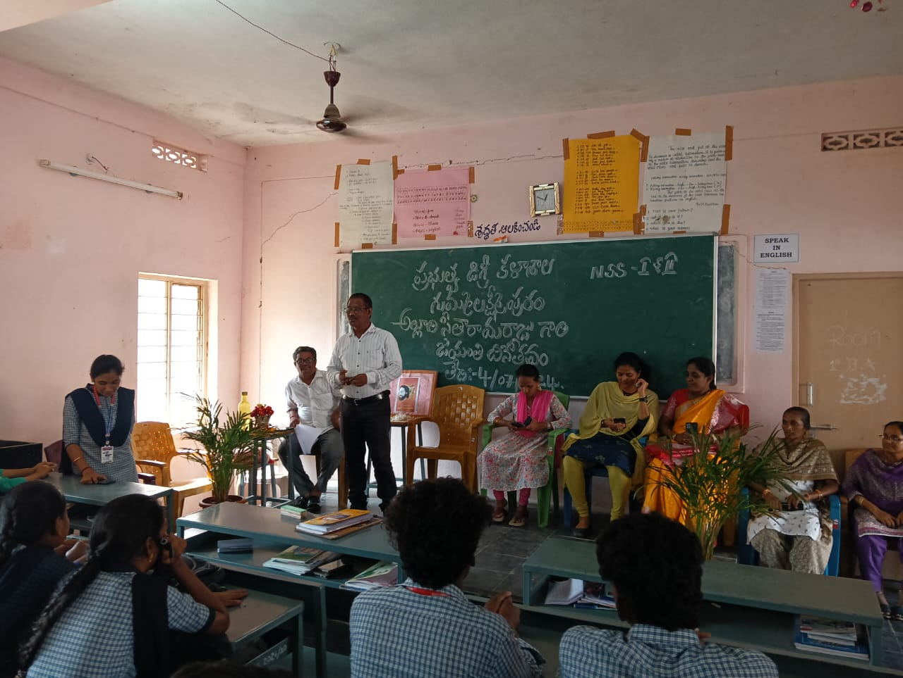VICE PRINCIPAL SIR DELIVERED MESSAGE**

**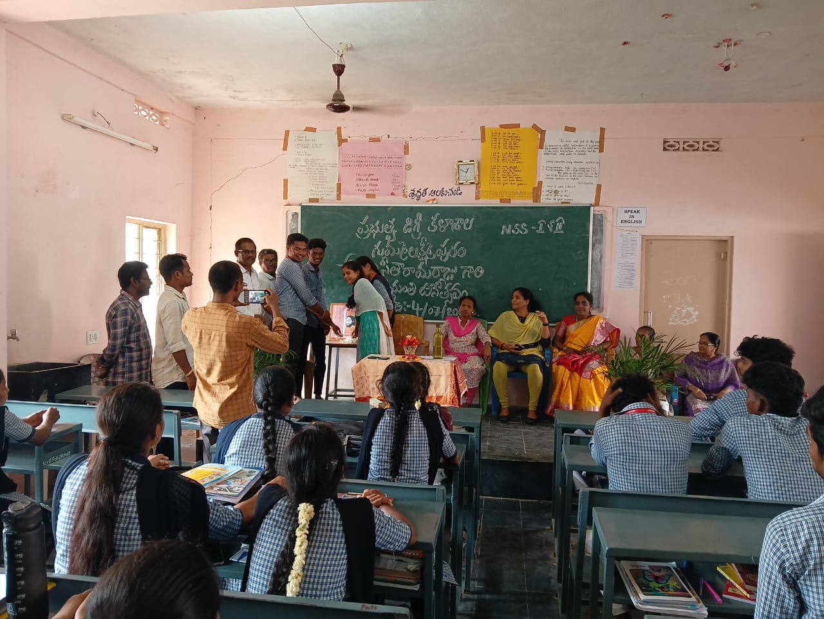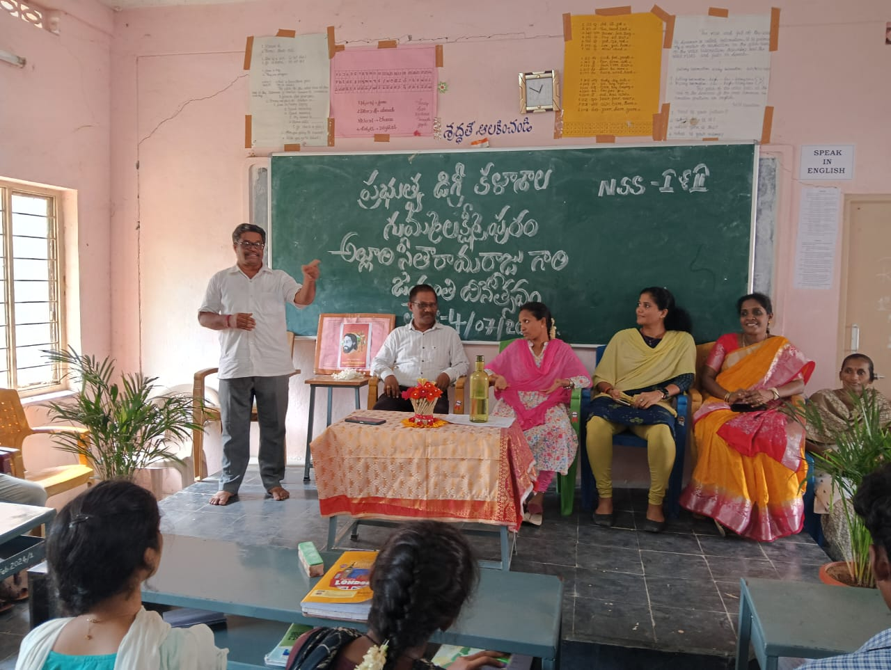*The main aim of conducting the event in the college is to make the student s participate in the event so that will share their knowledge about the veteran, Alluri seetararamaraju who was a great politician ,and great freedom fighter, braveness during the freedom struggle .***